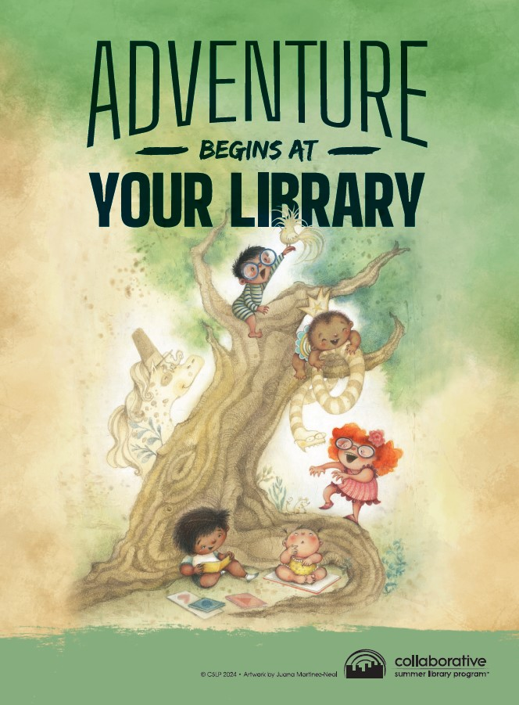

Adventure Begins at the Sweet Springs Public Library this summer! Come join our Summer Reading Program…June 4-July 26th. Rules and forms can be picked up at the library.